**CS502 - Fall 2022.**

**ASSIGNMENT # 01.**

Name: Abdul Rehman.

VU ID: BC220424444.

**Question No. 1:**

**(a)** Consider the C++ code, you need to write how many times each statement executes in the blanks given against each statement.

int x = 0, y = 0; **1 times.**

for (int i = 0; i < N; i++) **n times.**

{

for (int j = 0; j < N; j++) **n2 times.**

{

x = x + j; **1 times.**

}

}

for(int k = 0; k < N; k++) **n times.**

y = y + k; **1 times.**

What will be the total time complexity of this code?

Time Complexity =?

**Answer:**

Time Complexity = 1 + n + n2 + 1 + n + 1.

Time Complexity = O(n2).

**(b)** Consider the following given code, you need to write how many times each statement executes in the blanks given against each statement.

for(int x = n/2; x <= n; i++)  **infinite times.**

{

for(int y = 1; y <= n; y = y*2) **infinite times.**

{

cout<<x<<y; **1 times.**

}

}

What will be the total time complexity of this code?

Time Complexity =?

**Answer:**

Time Complexity = infinite + infinite + 1.

Time Complexity = O(NULL).

**Question No. 2:**

Take your VU Student ID as a list of digits and sort it in **Ascending Order** using **Merge Sort**.

**For Example:**

Consider the following digits as a list of a student ID (*i.e*., BS217683249) having name "***ABC***”:

2, 1, 7, 6, 8, 3, 2, 4, 9

Note: You are required to draw a separate tree structure for both the **Divide** and **Combine** phase of Merge Sort mechanism.

Finally, you will have two tree structures, one for divide phase and other for combine phase. It is required to perform all the steps to get full marks.

**Answer:**

My VU ID: BC220424444.

According to given scenario first, we will divide the VU ID in Divide Phase of Merge Sort.

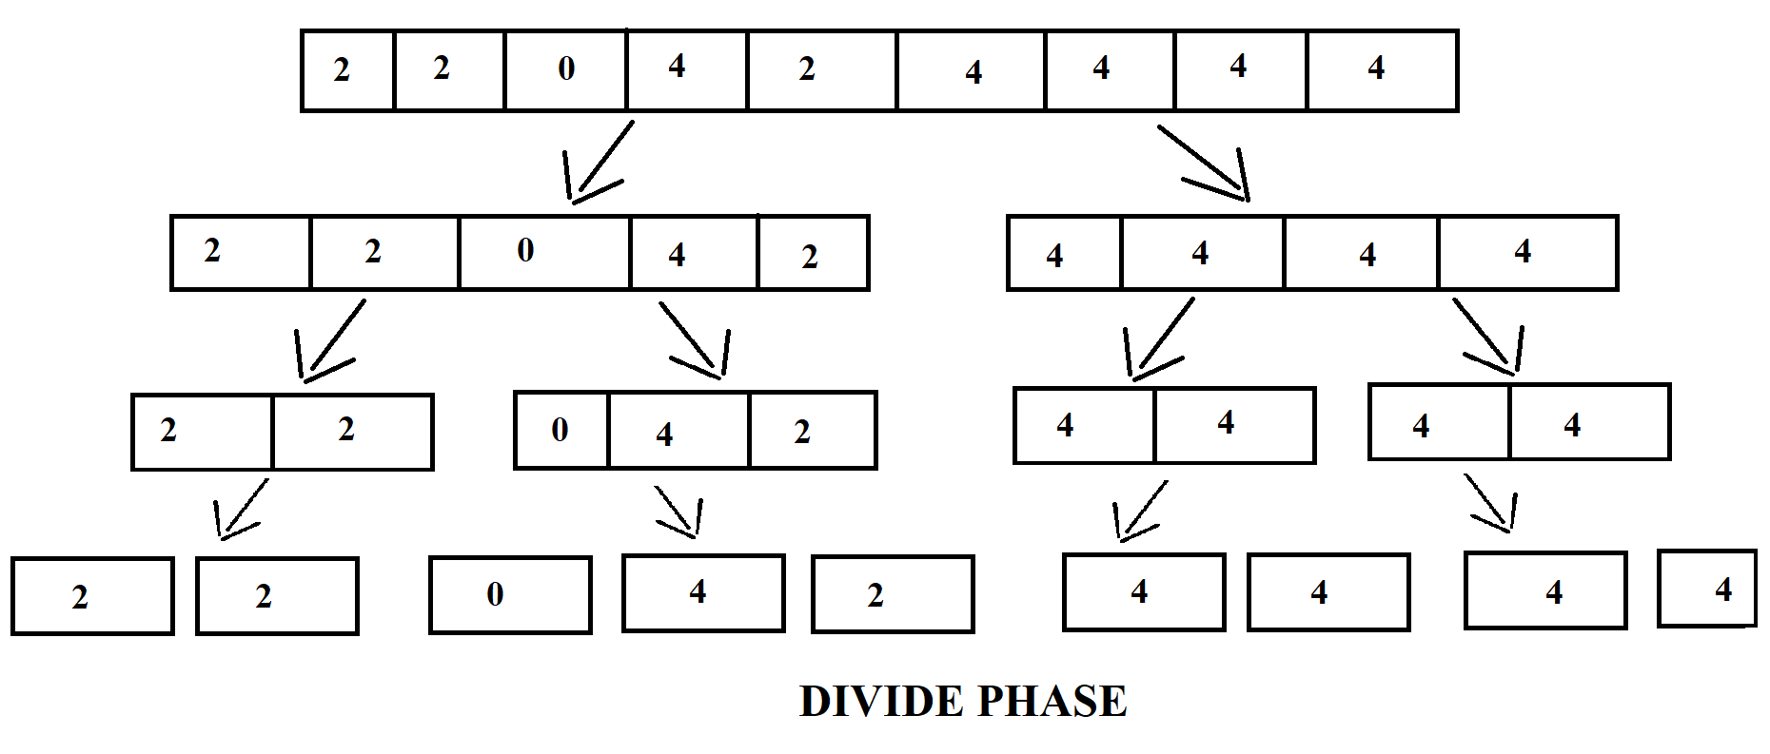

Now, we will combine the value from smaller to larger one by one in combine phase.

